# 

B.Tech Mechanical, FINAL YEAR project

By: Devanshu Gaur



Under the guidance of dR. ALI HASAN, DEPARTMENT OF MECHANICAL ENGINEERING, JAMIA MILLIA ISLAMIA

CONTENTS

1. Problem Statement
2. Methodology
3. Work Chapter-1: Introduction and Literary Review
4. Work Chapter-2: Kinematic Chains, Topological Graphs and Matrix formation
5. Work Chapter-3: Determination of distinct mechanisms
6. Work Chapter-4: Analysis of 10-bar kinematic chains
7. Results & Discussion
8. Conclusions
9. Scope for Future Work
10. References

**i) Problem Statement:**

Study of characterization and identification of planar mechanism kinematic chains (K.C).

**ii) Methodology:**

- Study of relevant literature on the given topic.

- Identify the given set of kinematic chains: 2 x 6 bar K.Cs + 16 x 8 bar K.Cs.

- Enumerate all possible kinematic inversions of each chain.

- Sketch these kinematic chains along with their corresponding topological graphs.

- Develop adjacency matrices for every single inversion of every K.C with the help of topological graphs.

- Calculate the various matrix parameters (such as sum of absolute values of polynomial coefficients and maximum absolute value of coefficients).

- Identify isomorphic inversions and determine the actual number of distinct mechanisms.

**iii) Work Chapter-1: Introduction and Literary Review:**

Basic Concepts:

We deﬁne a material body as a rigid body if the distance between any two points of the body remains constant. In reality, rigid bodies do not exist, since all known materials deform under stress. However, we may consider a body as rigid if its deformation under stress is negligibly small. The use of rigid bodies makes the study of kinematics of mechanisms easier. However, for light-weight and high-speed

mechanisms, the elastic effects of a material body may become signiﬁcant and must

be taken into consideration. In this text, unless otherwise stated, we shall treat all

bodies as being rigid. A rigid body may be considered as being inﬁnitely large for

study of the kinematics of mechanisms.

The individual rigid bodies making up a machine or mechanism are called members

or links. For convenience, certain nonrigid bodies such as chains, cables, or belts,

which momentarily serve the same function as rigid bodies, may also be considered

as links. From the kinematics point of view, two or more members connected together

such that no relative motion can occur between them will be considered as one link.

The links in a machine or mechanism are connected in pairs. The connection

between two links is called a joint. A joint physically adds some constraint(s) to the

relative motion between the two members. The kind of relative motion permitted by

a joint is governed by the form of the surfaces of contact between the two members.

The surface of contact of a link is called a pair element. Two such paired elements

form a kinematic pair.

We classify kinematic pairs into lower pairs and higher pairs according to the

contact between the paired elements. A kinematic pair is called a lower pair if one

pair of the element not only forms the envelope of the other, but also encloses it. The

forms of the lower pair elements are geometrically identical, one being solid while

the other is hollow. Lower pairs have surface contact. On the other hand, if the pair

elements do not enclose each other, we call the pair a higher pair. Higher pairs have

line or point contact between the element surfaces.

There are six lower pairs and two higher pairs that are frequently used in mecha-

nisms as shown in Figure 1.2. We describe each of them brieﬂy as follows.

A revolute joint, R, permits two paired elements to rotate with respect to one another

about an axis that is deﬁned by the geometry of the joint. Therefore, the revolute joint

is a one degree-of-freedom (dof) joint; that is, it imposes ﬁve constraints on the paired

elements. The revolute joint is sometimes called a turning pair, a hinge, or a pin joint.

A prismatic joint, P, allows two paired elements to slide with respect to each other

along an axis deﬁned by the geometry of the joint. Similar to a revolute joint, the

prismatic joint is a one-dof joint. It imposes ﬁve constraints on the paired elements.

The prismatic joint is also called a sliding pair.

A cylindric joint, C, permits a rotation about and an independent translation along

an axis deﬁned by the geometry of the joint. Therefore, the cylindric joint is a two-

dof joint. It imposes four constraints on the paired elements. A cylindric joint is

kinematically equivalent to a revolute joint in series with a prismatic joint with their

joint axes parallel to or coincident with each other.

A helical joint, H, allows two paired elements to rotate about and translate along

an axis deﬁned by the geometry of the joint. However, the translation is related to

the rotation by the pitch of the joint. Hence, the helical joint is a one-dof joint. It

imposes ﬁve constraints on the paired elements. The helical joint is sometimes called

a screw pairs.

A spherical joint, S, allows one element to rotate freely with respect to the other

about the center of a sphere. It is a ball-and-socket joint that permits no translations

between the paired elements. Hence, the spherical joint is a three-dof joint; that is, it

imposes three constraints on the paired elements. A spherical joint is kinematically

equivalent to three intersecting revolute joints.

A plane pair, E, permits two translational degrees of freedom on a plane and a

rotational degree of freedom about an axis that is normal to the plane of contact.

Hence, the plane pair is a three-dof joint; that is, it imposes three constraints on the

paired elements.

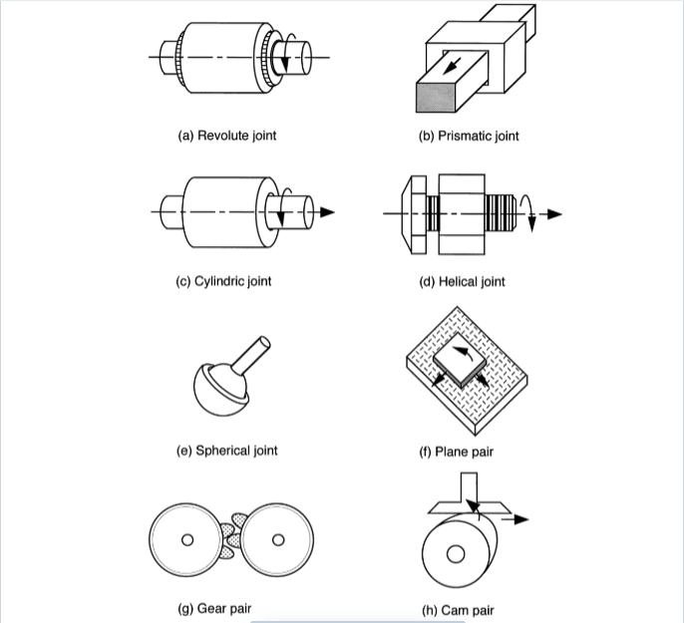

Kinematic Chains, Mechanisms, and Machines:

A kinematic chain is an assemblage of links, or rigid bodies, that are connected

by joints. If every link in a kinematic chain is connected to every other link by one

and only one path, it is called an open-loop chain. On the other hand, if every link is

connected to every other link by at least two distinct paths, the kinematic chain forms

one or more closed loops and is called a closed-loop chain. Clearly, it is possible

for a kinematic chain to contain both closed- and open-loop chains. We call such a

kinematic chain a hybrid kinematic chain.

When one of the links in a kinematic chain is ﬁxed to the ground or base, it is called

a mechanism. The link that is ﬁxed to the base is called the ﬁxed link. As the input

link(s) move with respect to the base, all other links perform constrained motions.

Thus, a mechanism is a device that transforms motion and/or torque from one or more

links to the others. For example, Figure 1.6 shows a crank-and-slider mechanism that

transforms a continuous rotation of the crank into a reciprocal motion of the slider

and vice versa.

When one or more mechanisms are assembled together with other hydraulic, pneu-

matic, and electrical components such that mechanical forces of nature can be com-

pelled to do work, we call such an assembly a machine. That is, a machine is an

assemblage of several components for the purpose of transforming external energy

into useful work.

Although the terms mechanism and machine are often used synonymously, in

reality there is a deﬁnite difference. Figure 1.7 shows a 6-axis milling machine

produced by Giddings &Lewis Machine Tools. The basic mechanism of the machine

consists of a moving platform, a ﬁxed base, and six supporting limbs. Each limb

is made up of two members that are connected to each other by a prismatic joint.

The upper end of each limb is connected to the moving platform by a universal

joint, whereas the lower end is connected to the base by a spherical joint. The

motion of the prismatic joint is controlled by a motor-driven ball screw. Together

it forms a parallel manipulator generally known as the Stewart-Gough manipulator.

Kinematic Inversions:

A mechanism is deﬁned by ﬁxing one of the links in a kinematic

chain to the ground. When different links of a kinematic chain are chosen as the ﬁxed

link, the relative motions between all the links are not altered. However, their motions

with respect to the ground may be completely different. The process of selecting

various links of a kinematic chain as the ﬁxed link is called kinematic inversion.

Applying kinematic inversion, many mechanisms can be derived from a given

kinematic chain. However, some of them may be structurally isomorphic with the

others. Figure 1.13 shows four inversions of a four-link chain. However, except for

the difference in link lengths, the mechanism shown in Figure 1.13a is structurally

isomorphic with that of Figure 1.13d; and the mechanism shown in Figure 1.13b is

structurally isomorphic with that of Figure 1.13c.

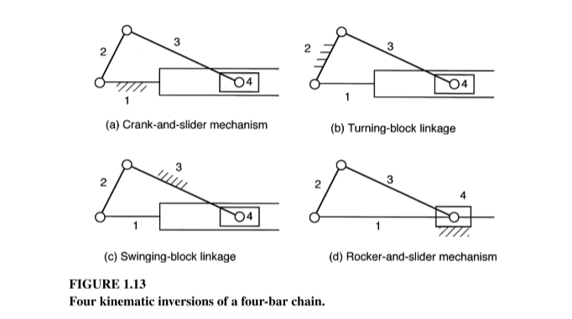

**Structural Representation:**

In a structural representation, each link of a mechanism is denoted by a polygon

whose vertices represent the kinematic pairs. Speciﬁcally, a binary link is represented

by a line with two end vertices, a ternary link is represented by a cross-hatched triangle

with three vertices, a quaternary link is represented by a cross-hatched quadrilateral

with four vertices, and so on. Figure 3.5 shows the structural representation of a

binary, ternary, and quaternary link. The vertices of a structural representation can

be colored or labeled for the identiﬁcation of pair connections. For example, plain

vertices shown in Figure 3.5 denote revolute joints, whereas solid vertices denote

gear pairs.

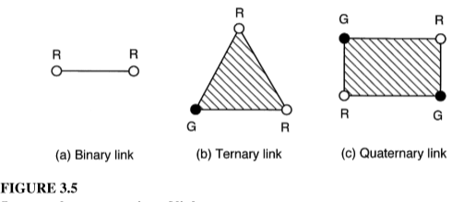

**LITERATURE REVIEW**

Design is an iterative process with many interactive phases. Many resources exist to support the designer, including many sources of information and an abundance of computational design tools.

The kinematic structure of a mechanism contains the essential information about

which link is connected to which other link by what type of joint. The kinematic

structure of a mechanism can be represented in several different ways. Some methods

of representation are fairly straightforward, whereas others may be rather abstract and

do not necessarily have a one-to-one correspondence. [1]

Given a kinematic chain, we can calculate the degree of freedom for it, which in turn tells us the number of variables that can be altered or the number of dimensions in which motion can occur [2]. Mathematically, degree of freedom can be calculated by the formula:

**F = 3(n-1) – 2j – h**

Where,

n = number of links

j = number of lower pairs

h = number of higher pairs

When the degree of freedom of any given mechanism is 1, it is called a constrained mechanism as it is constrained in one dimension.

The relation between the number of distinct possible mechanisms formed by a given a kinematic chain are, in theory, equal to the number of links present in the kinematic chain. However, some mechanisms may form an equivalent representation of each other, thereby being isomorphic and not leading to any new *distinct* mechanisms. So, it is necessary to determine the exact number of possible distinct inversions that can be obtained from a particular kinematic chain, as is pointed out by Dr. Hasan [3]

A simple way to analyze kinematic chains is to study and evaluate their topological graphs, convert them into matrices and evaluate certain key parameters (such as eigen values) for each of the matrices.

Various researchers proposed have methods to identify isomorphism. Many attempts have been made in the past to solve this problem using the graph theory, a comprehensive study on which has been carried out by Vinjamuri Venkata Kamesh. [4]

In this study, we shall try to understand the basic nature of graph theory analysis and how we can apply it to eliminate isomorphic mechanisms and identify the true number of distinct mechanisms that can be obtained from any given kinematic chain.

**Graph Representation of kinematic chains:**

Since a kinematic chain is a collection of links connected by joints, this link and joint

assemblage can be represented in a more abstract form called the graph representation.

In a graph representation, the vertices denote links and the edges denote joints of a

mechanism. The edge connection between vertices corresponds to the pair connection

between links. To distinguish the differences between various pair connections, the

edges can be labeled or colored. For example, the gear pairs in a gear train can

be represented by thick edges and the turning pairs (revolute joints) by thin edges.

Furthermore, the thin edges can be labeled according to the locations of their axes.

The graph of a mechanism is deﬁned similarly with only one addition; the ver-

tex denoting the ﬁxed link is labeled accordingly, usually with two small concentric

circles.

Advantages of Using Graph Representation:

The advantages of using the graph representation are:

1. Many network properties of graphs are directly applicable. For example, we

can apply Euler’s equation to obtain the loop mobility criterion of mechanisms

directly.

2. The structural topology of a mechanism can be uniquely identiﬁed. Using graph

representation, the similarity and difference between two different mechanism

embodiments can be easily recognized.

3. Graphs may be used as an aid for the development of computer-aided kinematic

and dynamic analysis of mechanisms. For example, Freudenstein and Yang [5]

applied the theory of fundamental circuits for the kinematic and static force

analysis of planar spur gear trains. The theory was subsequently extended

to the kinematic analysis of bevel-gear robotic mechanisms [6]

4. Graph theory may be employed for systematic enumeration of mechanisms. [7].

5. Graphs can be used for systematic classiﬁcation of mechanisms. A single atlas

of graphs can be used to enumerate an enormous number of mechanisms. This obviates the need for an individual atlas of kinematic chains tailored

for each application.

6. Graphs can be used as an aid in automated sketching of mechanisms.

In order to design the kinematic chains and their respective kinematic graphs, we take the help of various designing software. Computer-aided design (CAD) software allows the development of three-dimensional (3-D) designs from which conventional two-dimensional orthographic views with automatic dimensioning can be produced. Manufacturing tool paths can be generated from the 3-D models, and in some cases, parts can be created directly from a 3-D database by using a rapid prototyping and manufacturing method (stereolithography)—paperless manufacturing! Another advantage of a 3-D database is that it allows rapid and accurate calculations of mass properties such as mass, location of the center of gravity, and mass moments of inertia. Other geometric properties such as areas and distances between points are likewise easily obtained. [8]

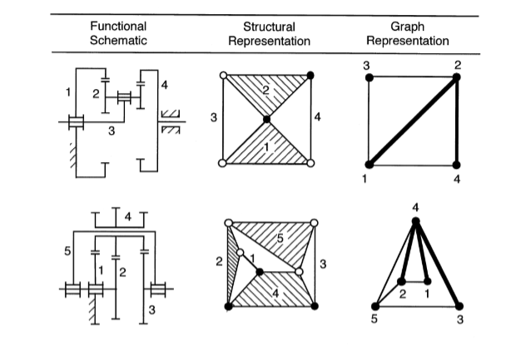

Once we obtain the topological graphs for any given kinematic chain, we then go on to convert these graphs into their matrix representation so that we can take help of computer analysis tools (such as MATLAB) to further evaluate the data corresponding to each of the inversions of a given kinematic chain.

Matrix Representation:

For convenience of computer programming, the kinematic structure of a kinematic

chain is represented by a graph and the graph is expressed in matrix form.

The most frequently used method is the link-to-link form of adjacency matrix. Other

methods of representation, such as the incidence matrix, circuit matrix, and path

matrix, are also useful for the identiﬁcation and classiﬁcation of mechanisms. Matrix

representations are particularly useful for computer aided enumeration of kinematic

structures of mechanisms. The two major types of matrices, as have been briefly enumerated by Dr. Hasan in his paper [9], are as follows:

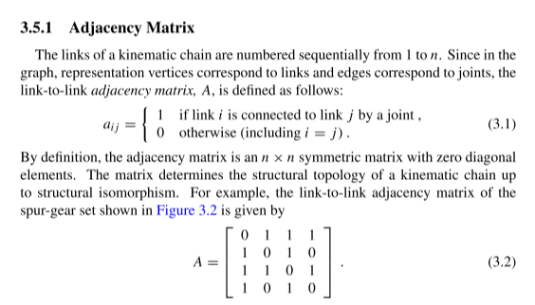

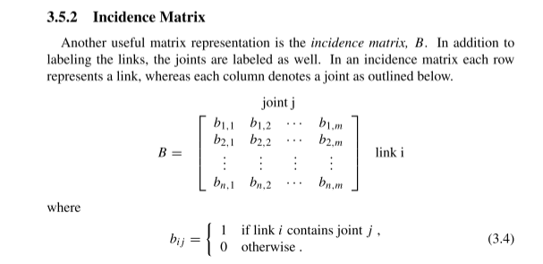

**iv) Work Chapter-2: Kinematic Chains, Topological Graphs and Matrix formation:**

A kinematic chain is an assemblage of links, or rigid bodies, that are connected

by joints. If every link in a kinematic chain is connected to every other link by one

and only one path, it is called an open-loop chain. On the other hand, if every link is

connected to every other link by at least two distinct paths, the kinematic chain forms

one or more closed loops and is called a closed-loop chain.

When one of the links in a kinematic chain is ﬁxed to the ground or base, it is called

a mechanism. Thus, a mechanism is a device that transforms motion and/or torque from one or more links to the others. For example, a crank-and-slider mechanism transforms a continuous rotation of the crank into a reciprocal motion of the slider and vice versa.

When one or more mechanisms are assembled together with other hydraulic, pneumatic, and electrical components such that mechanical forces of nature can be compelled to do work, we call such an assembly a machine.

**Sketches of Kinematic chains along with their topological graphs are shown below:**

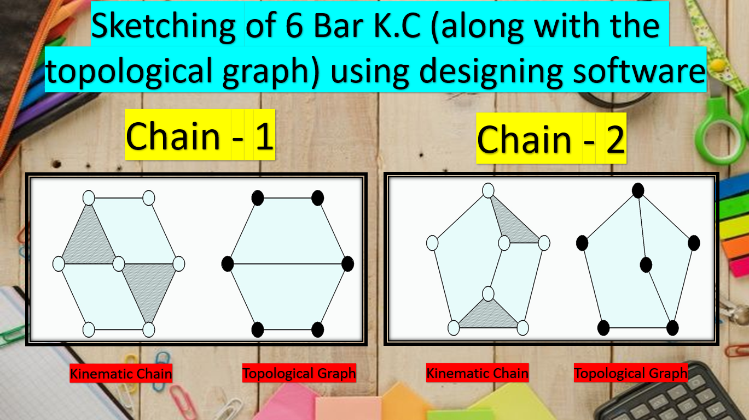

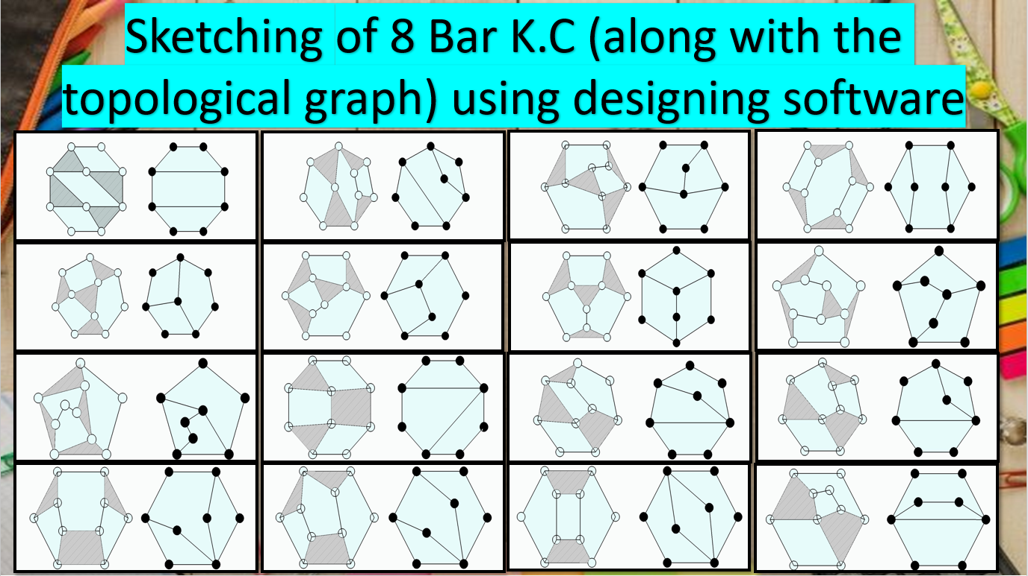

Visual representation of 16 8-bar K.Cs along with their topological graphs, as sketched using a designing software.

**Conversion of topological graphs to matrices:**

The links of a kinematic chain are numbered sequentially from 1 to n. Since in the graph, representation vertices correspond to links and edges correspond to joints, the link-to-link adjacency matrix, A, is defined as follows:

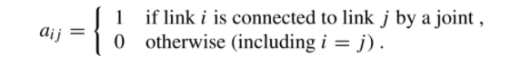

By definition, the adjacency matrix is an n × n symmetric matrix with zero diagonal elements. The matrix determines the structural topology of a kinematic chain up to structural isomorphism. For example:

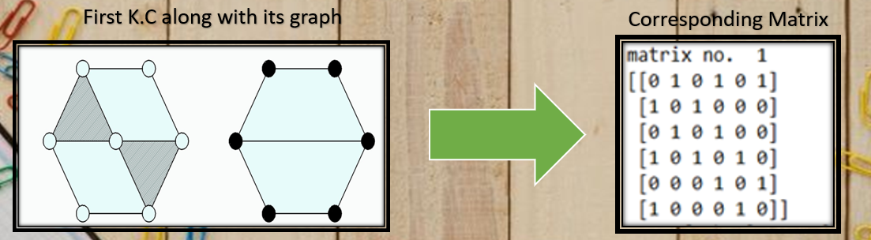

Using the above illustrated process, we convert each K.C into its graphical form and then using these graphs, construct matrices for every inversion of each of the K.C.

**v) Work Chapter-3: Determination of mechanisms:**

The mathematical principle used here is that: If 2 matrices are similar, their polynomial coefficients are also similar.

For an 8 bar K.C, we theoretically expect it to give 8 distinct mechanisms (one each formed by fixing each of the links). But this is not necessarily the case.

This happens due to isomorphism. Sometimes fixing two separate links can result in the formation of 2 mechanisms which operate in identical manner. Thus, both these inversions together form only 1 distinct mechanism.

If 2 inversions form the same mechanism, we will see that the sum of absolute values of coefficient of polynomials and maximum absolute value of coefficient of polynomials, as calculated through the mathematical analysis of their respective matrices, will both be same.

For example:

Let’s take K.C – 5, which has 8 links and is therefore expected to give 8 distinct mechanisms.

However, two of the inversions yield identical mechanisms and therefore we get only 7 distinct mechanisms. This is illustrated below:

We observe that the sum of absolute values of characteristic polynomial coefficients and the maximum absolute value of characteristic polynomial coefficients (from the given table) are same for the following inversions:

* Inversions d & f

Therefore, the given kinematic chain has 7 distinct possible mechanisms, as opposed to 8 distinct mechanisms (what we might have initially thought given the number of links in this kinematic chain).

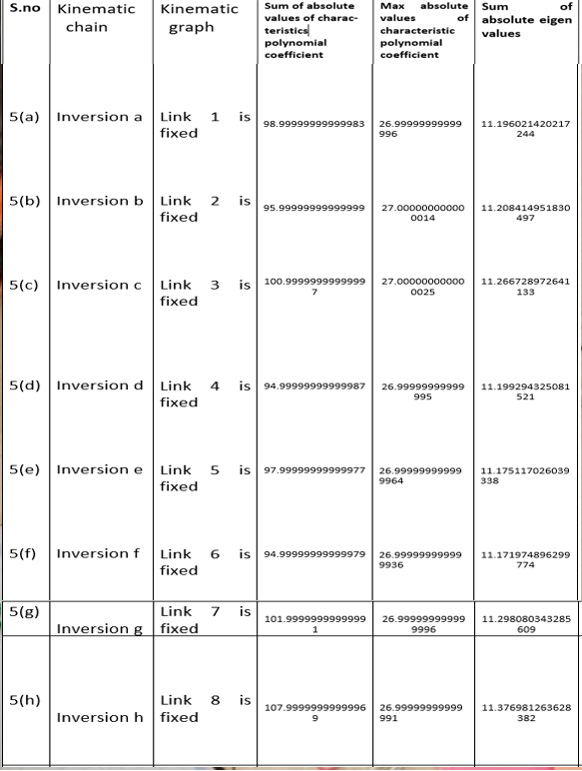

Similar work has been done for each of the 18 kinematic chains, the detailed analysis of which is enclosed in **Appendix A**.

**vi) Work Chapter - 4: Analysis of 10-bar Kinematic chains**

We know reiterate the entire process followed above for 10-bar kinematic chains. Since the number of kinematic chains (10-bar) is too high, we will consider only 10-bar Group A kinematic chains in our study which include a total of 50 kinematic chains.

Our objective will again be to identify isomorphic inversions and thereby determine the number of distinct mechanisms possible.

Through our study we realize that adjacency matrix formation method does not apply here. Therefore, we use another method called J-J matrix method.

**J-J Matrix method:**

J-J stands for Joint-Joint matrix and it is based upon the connectivity of the joints through the links and defined, as a square symmetric matrix of size n x n, where n is the number of joints in a kinematic chain [12].

In 10 bar (group A) kinematic chains, we get to observe a total of 13 joints. Therefore, our matrix will be of the size 13 by 13.

**Sample work procedure:**

We collect kinematic chains from the available literature and convert them into their corresponding topological graphs. This is shows as follows:

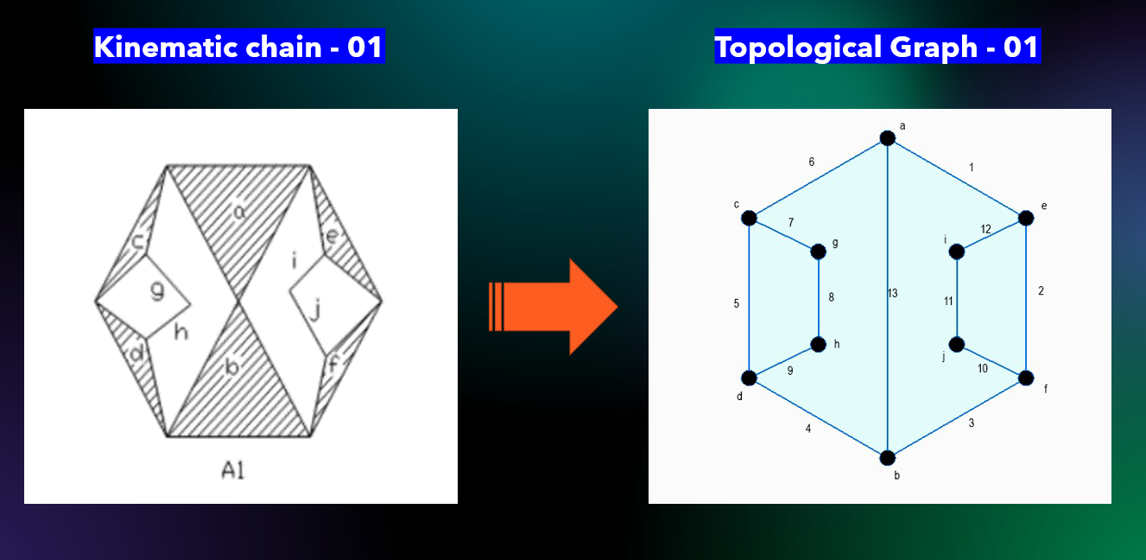

We then develop a J-J matrix corresponding to each of these topological graphs as follows:

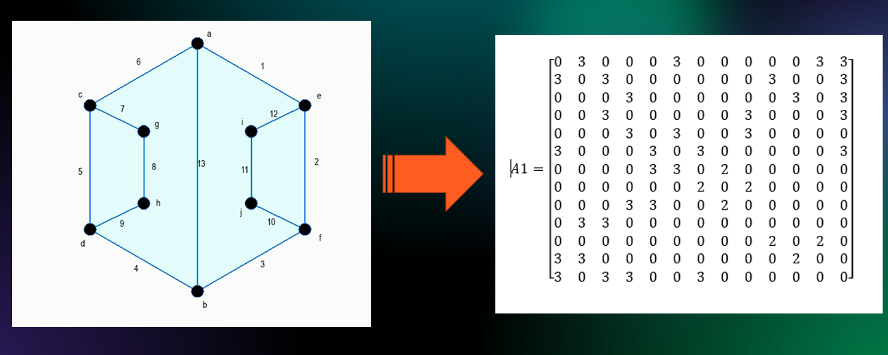

We then form matrices for each of the inversions of each of the kinematic chains in group – A and calculate the relevant matrix parameters as follows:

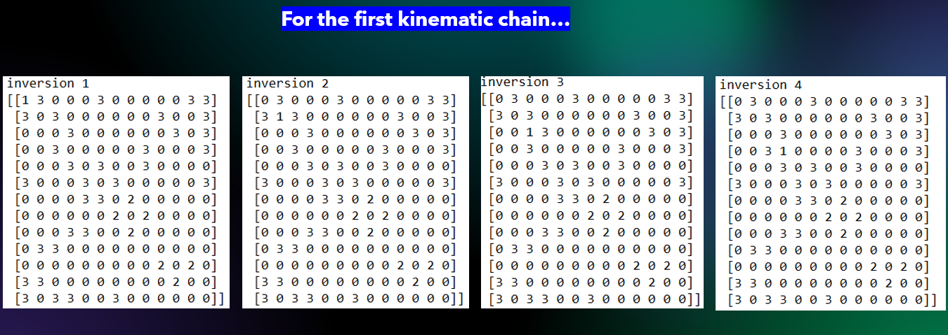

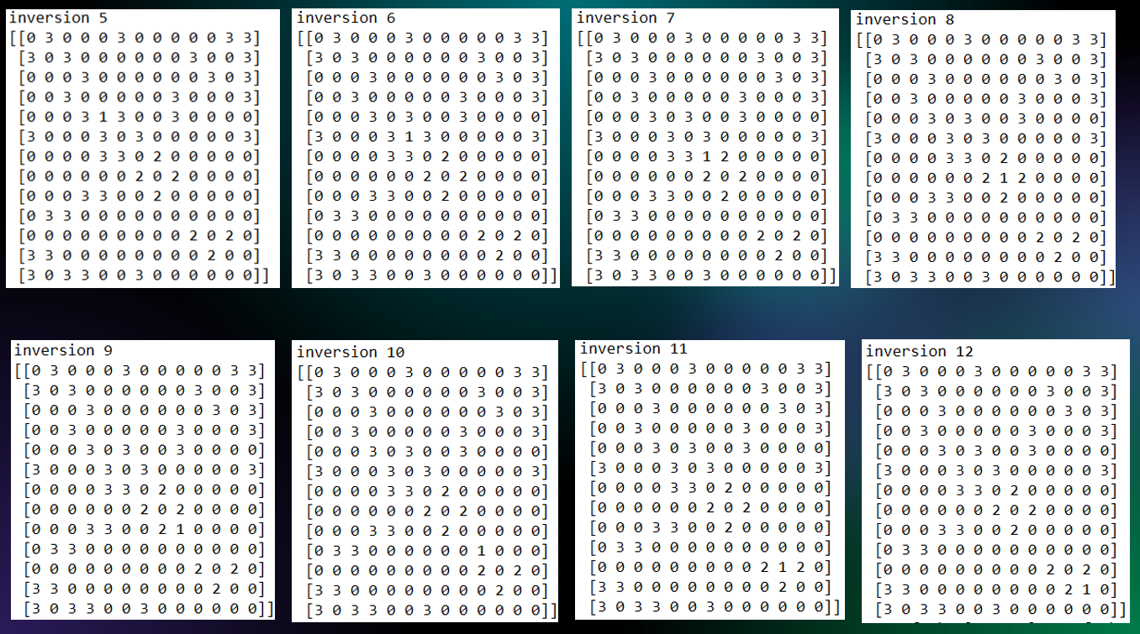

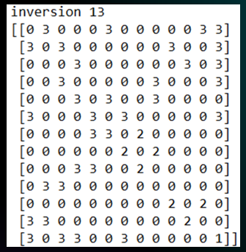

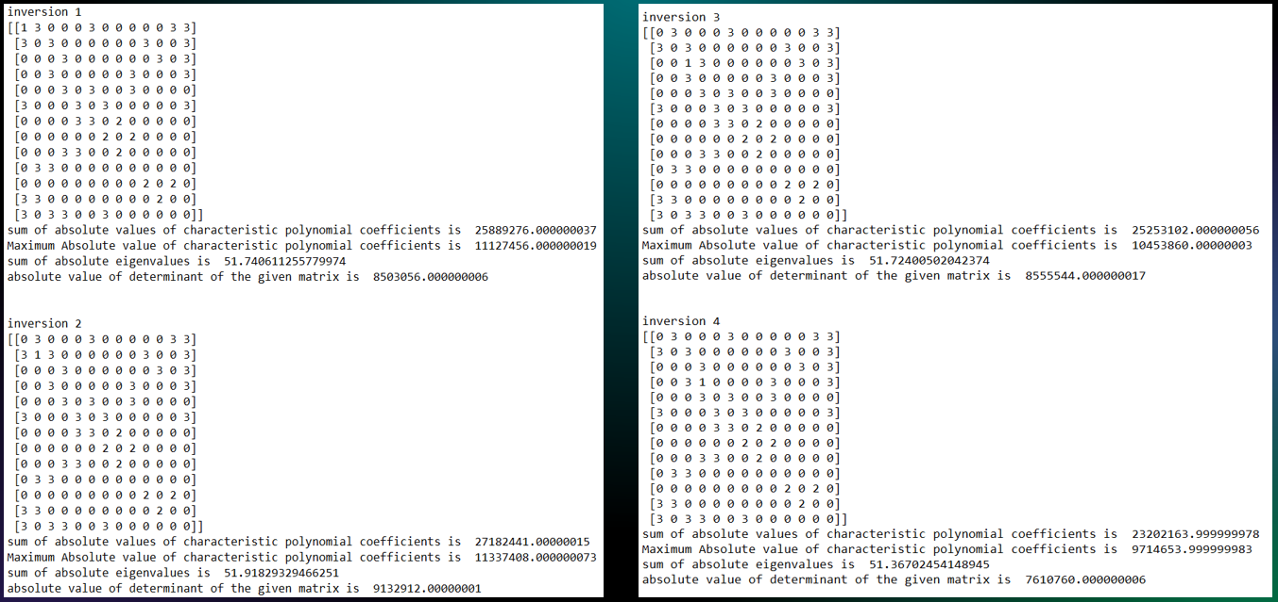

In this particular case, we observe that inversions 1 and 3 are isomorphic since their relevant parameters are fairly similar.

We reiterate this process for every K.C to determine the number of distinct possible mechanisms.

The entire details on this have been attached in the file: Appendix B.

The working of relevant computer codes used to generate these outputs have been explained in our presentation.

**vii) Results & Discussion:**

Each of the 18 kinematic chains (along with their inversions) have been studied and analyzed in depth, and the number of distinct possible mechanisms formed by each kinematic chain have been calculated and documented.

**A total of 5 distinct mechanisms for 6-bar kinematic chain, 71 distinct mechanisms for 8-bar kinematic chain and 342 distinct mechanisms for 10-bar kinematic chains (group-A) were calculated, which is consistent with the available literature.**

This finds application in designing as we are able to determine the possible number of distinct mechanisms using simple mathematical and analytical tools without physically having to build systems and test them.

**viii) Conclusion:**

The methods studied herein are simple, clear and easy to employ and they give us a comprehensive insight into identifying various types of mechanisms and distinguishing them from their isomorphic counterparts. The mathematical calculations involved can get complicated but with the use of analytical software, even more complicated kinematic chains (those involving higher number of links) can be studied within a feasible amount of time.

**x) References:**

[1] Book: “Mechanism design – Enumeration of kinematic structures according to function” by Lung-Wen Tsai, University of California

[2] Book: “Vector Mechanics for engineers – Statistics and Dynamics” by Ferdinand P. Beer and E. Russell Johnston

[3] An efficient algorithm for distinct inversions and isomorphism detection in kinematic chains by [Syed Shane Haider Rizvi](https://www.sciencedirect.com/science/article/pii/S2213020916300647#!), [Ali Hasan](https://www.sciencedirect.com/science/article/pii/S2213020916300647#!), [R.A.Khan](https://www.sciencedirect.com/science/article/pii/S2213020916300647#!), Jamia Millia Islamia (Central University), New Delhi

[4] ISOMORPHISM IN PLANAR KINEMATIC CHAINS - A CASE STUDY IN GRAPH THEORY ALGORITHM - Vinjamuri Venkata KameshProfessor of Mechanical Engineering,Aditya Engineering College(A) SURAMPALEM-533 437

[5] Freudenstein, F. and Yang, A.T., 1972, Kinematics and Statics of a Coupled

Epicyclic Spur-Gear Train, Mechanisms and Machine Theory, 7, 263–275.

[6] Tsai, L.W., 1988, The Kinematics of Spatial Robotic Bevel-Gear Trains, IEEE

Journal of Robotics and Automation, 4, 2, 150–156.

[7] Yan, H.S. and Chen, J.J., 1985, Creative Design of a Wheel Damping Mecha-

nism, Mechanism and Machine Theory, 20, 6, 597–600.

[8] Book: Shigley’s Mechanical Engineering Design textbook (9th edition)

[9] “A Study of Structural Representation of Mechanisms Kinematic Chains” – Dr. Ali Hasan

[10] Mruthyunjaya T.S. and Balasubramanium H.R., “In Quest of Reliable and Efficient Computational Test for Detection of Isomorphism in Kinematic Chains,” *Mech. Mach theory*, Vol. 22, No 4, pp 131-139, 1987.

[11] Chapter-4: Identification and Isomorphisms, Hasan A, Ph.D thesis .Some Studies on Characterization and Identification of Kinematic Chains and Mechanisms. Jamia Millia Islamia, New Delhi,India,2007.

[12] Ambeker, 1987(i) Ambeker A. G. and Agrawal V. P., “Canonical Numbering of Kinematic Chains and Isomorphism Problem: Min. Code”, Mech. Mach theory, Vol. 22, No 4, pp 453-461, 1987.

[13] Castellet and Thomas,1999 Castellet A.and Thomas F. , “ Characterization of the Self-Motion Set of the Orthogonal Spherical Mechanism”, Mech. Mach. Theory, Vol. 34, pp. 59-88, 1999.

[14] Ghosh and Mallik, 1988 Amitabha Ghosh and Ashok Kumar Mallik, “Theory of Mechanisms and Machines”, East – West Press Pvt. Ltd., New Delhi, pp. II Edition 1988